French herding trials
Most people are familiar with the classic border collie trials of “BABE” fame and a few have perhaps heard of German herding trials, but very few seem to be aware that there have been herding trials in France for over a hundred years. Even fewer seem to know how it impacts Belgians.
In most professions, there tends to be a competition within that profession as to “who is best” and herding is no different. “My dog is better than your dog” probably started with the second domesticated wolf. Herding is no exception to this. Herding competitions to find who has the dog that can best manage livestock have occurred at markets or even when two neighboring herdsmen got together. Formal events started with the “International Sheepdog Association -- ISDS – in the UK, and were instrumental in developing the modern border collie. In 1873 the first recorded sheep dog trials were held in Bala, North Wales, but it was not until 33 years later that the International Sheep Dog Society (ISDS) was formed. Formal dog events took a bit longer in Europe. In 1892, a herding trial was held in Cureghem, Brussels. In 1896, France started hosting herding trials. The course initially was much like that of the Brussels trials, although the initial flock was larger, being 15 head. A diagram from the Scientific American article is shown below:
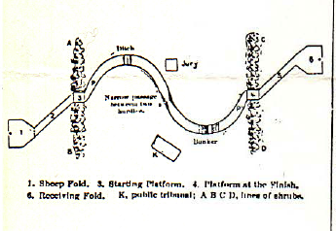
Over the years, the trials transformed in terms of rules, but despite interruptions due to war, the trials continued through to this day. While never numerous, Belgian herding dogs have participated in these events from its inception. In 2009, a Malinois qualified in the level 1 trials.
Originally the trials were limited to professionals. In the late 1990s, the then head of the French herding program, Le Goff, visited the US to discuss with American Herding Breed Association officials on how the AHBA handled amateur participants. Following this visit, the French program was opened to amateurs. In 2009, the rules were modified in several ways. The number of livestock required was reduced and a “EU” system was established, which had a “ISDS” type course for Border Collies and Kelpies, and a “traditional” course for all other breeds.
A tending course differs from a “ISDS” course in that the dog is expected to work a larger number of stock, to do differing tasks and to work much more close to the stock rather than at a great distance. The stock are expected to be well familiar with being worked by dogs and taken down roads rather than living in open pastures with few interactions with dogs. In the US, the most commonly known tending course is the AKC “C” course, which is very loosely based on the German “HGH” herding trials. So, what IS the French course program and how does it differ from AKC C and the German HGH?
First, unlike the current AKC program and the German program which are “sheep only”, the French program allows for both sheep and cattle. In the French cattle events, 5 head of cattle are used, and it is expected that these will be at least
fifteen months and used to being handled by a dog. It is expected that spectators will follow the course. The area required is a little over 7 acres. A circular area is marked and the handler must stay there while sending the dog for a gather. The dog must gather the cattle and bring them to the circle and hold them there. So, unlike a HGH or a C course, a straightforward gather, with the dog fetching the stock is required. It’s expected that the gather for a level III dog will be about 330 feet. There are panels or “posts” and the dog must keep the stock within these, then down an aisle way or chute. A “maltese cross” obstacle is included and the stock must transit the correct path rather than taking a wrong turn. A trailer load is required – the dog must hold the cattle while the trailer door is opened, then bring and load the cattle. In format, the requirements are remarkably similar to the Australian Shepherd Club of America “ranch trial course” rules.
In the sheep events, a group of at least 15 and no more than 80 head is used. This is smaller than the AKC requirements of 20 -100 and the HGH requirements of 300 or so. Dogs must be at least one year of age. Border collies and Kelpies are not allowed on the traditional course but may participate in the “inter race” course. The dog is required to jump into the enclosure, which is the same as HGH and which is allowed in AKC C. However, the dog is expected to work the sheep inside the pen by moving them to the side while the handler inspects (or simulates feeding) the stock. This task is unique to the French trial system. In the HGH and in AKC “C” the gate to the pen is left open for the repen. In the French system, the gate is closed, and one of the tasks is for the dog to halt and hold the stock while the gate is opened for the repen. In AKC there is only one required “obstacle”, the bridge. In the French rules, there should be at least 2 and preferably 3 obstacles, which may be a bridge, a narrow passage, passage between crops, hedges, or sorting pen. It is preferred for the dog to DRIVE the stock through such passages, going behind the stock to push them, with the handler allowed to follow behind the dog. Like the HGH and C, there is a graze required, but it is not marked by furrows. Instead, stakes mark the four corners. Moreover, the size of the graze is much smaller – about 50 x 50 feet. As with C and the HGH, the dog should contain the stock in the graze area and the stock should settle sufficiently to graze without exiting the designated area. During the graze, the handler is required to catch and hold a sheep. The dog is expected to move the stock so that the handler can do this and then to maintain control of the herd while the handler is dealing with the individual animal. As with the HGH and the C course, there is a car passage. Unlike these, the French rules require that there be an area where the stock can “lean” – in other words, a fence so that the dog can keep the flock against the fence. The course has at least 2, often more stops where the dog must halt and hold the flock while the handler makes sure that further progress is “safe”.
Below is a diagram of a typical modern French course:

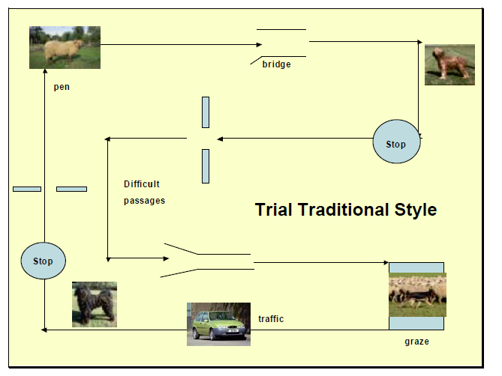
WTCH/HTCH Nyjella Ceres Kuymal doing a graze in the open desert.
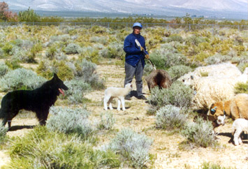

History of the ISDS - http://www.isds.org.uk/society/function_purpose/history.html
L'Historique du Berger Belge (History of the Belgian Sheepdog), by Georges Van Ceulebroeck, 1983, Concord/Imprimerie de Charleroi, Presles, Belgium See also http://www.kuymal.com/BreedingHerdingArticles.html
May 7, 1898 Scientific American. Article “completion of Shepherd’s dogs at Angerville [Normandy]”.
http://cun-troupeaux.fr/fr/content/t01-estivareilles-2009 Interestingly, this dog lives in Belgium (see http://www.facebook.com/profile.php?id=1083811505)
Personal participation. 1997
http://cun-troupeaux.fr/fr/content/ir-bovins-r%C3%A8glement
http://cun-troupeaux.fr/en/content/traditional-rules

